# Module Creation in Eclipse

1. Right click in Project Explorer window.

New --> Dynamic Web Project

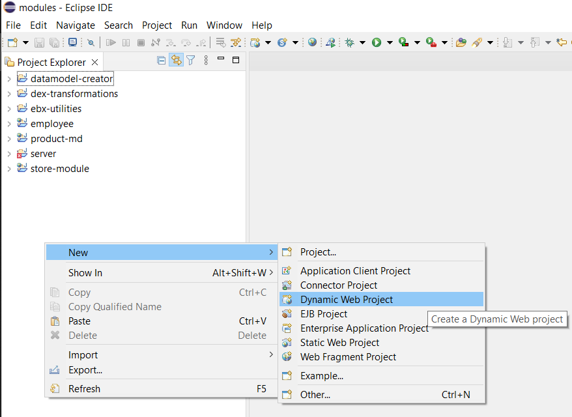

In New Dynamic Web Project enter the module name.

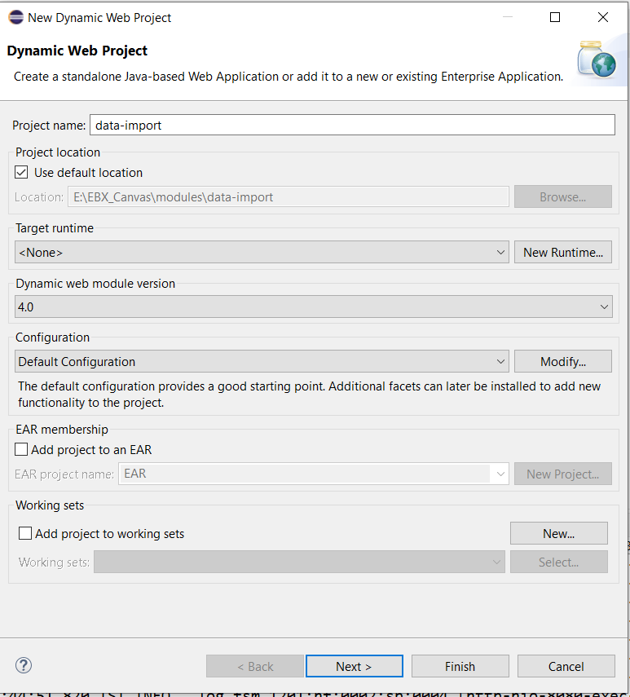

Click Next ---> Next on Web Module screen select the “Generate web.xml deployment description” checkbox.

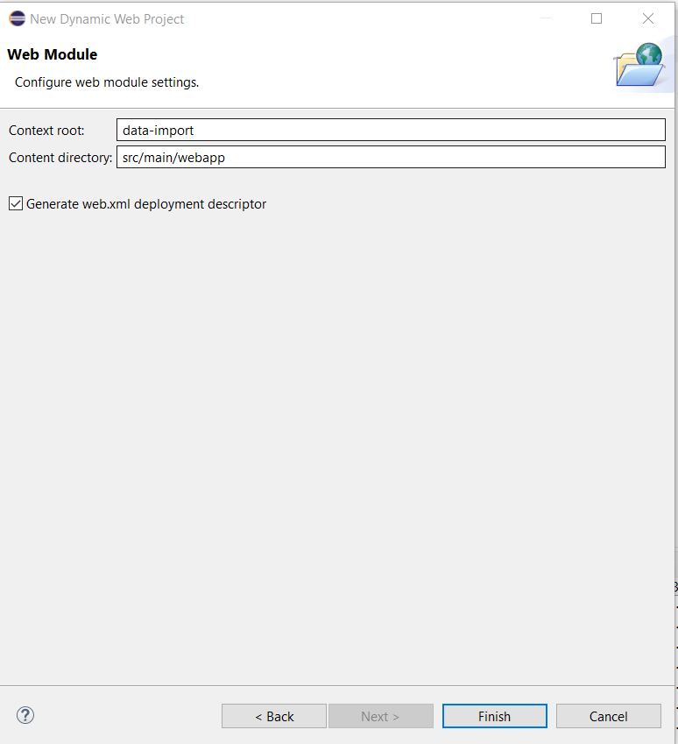

Click Finish. This will generate the module folder in the eclipse workspace.

# Module Registration with EBX

Create appropriate packages in the newly created module.

1. Right click on the src/main/java. Then New --> Package.

Provide the name of the module and click Finish.

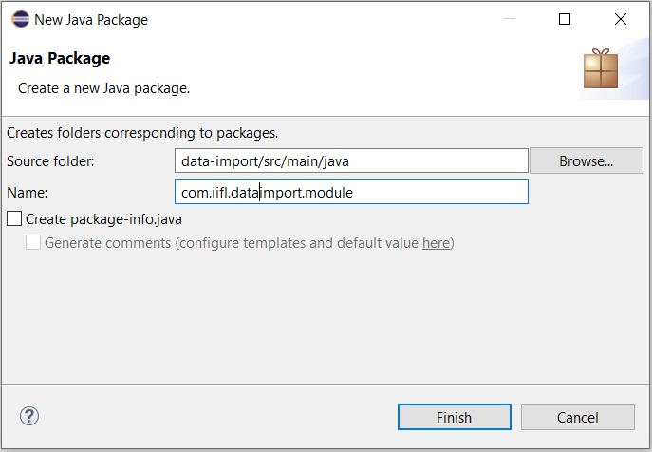

1. On the newly created package add the dependency jar in the module configuration.

Right click on the module folder. Build Path --> Configure Build Path.

In the “Java Build Path” --> Libraries add the EBX jar required for using the EBX API.

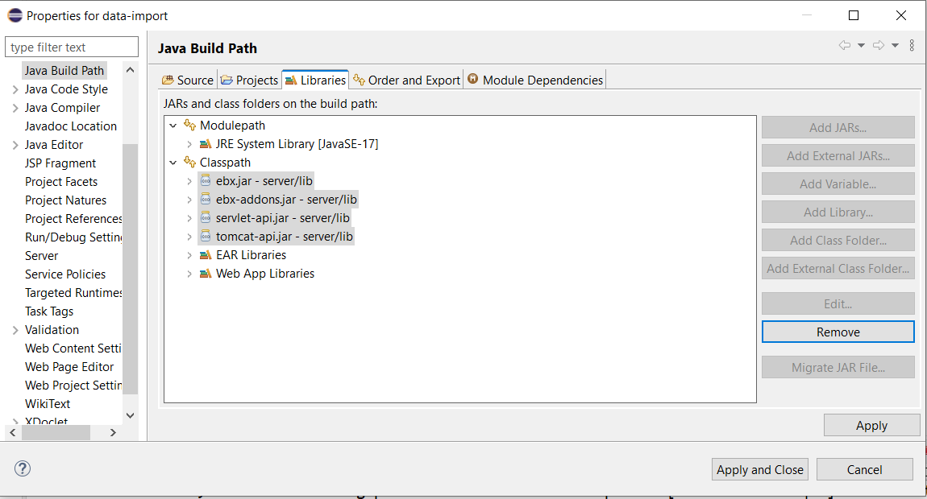

1. Also set the java compiler version to same as that of on which the EBX is running. (In this document it is Java 11)

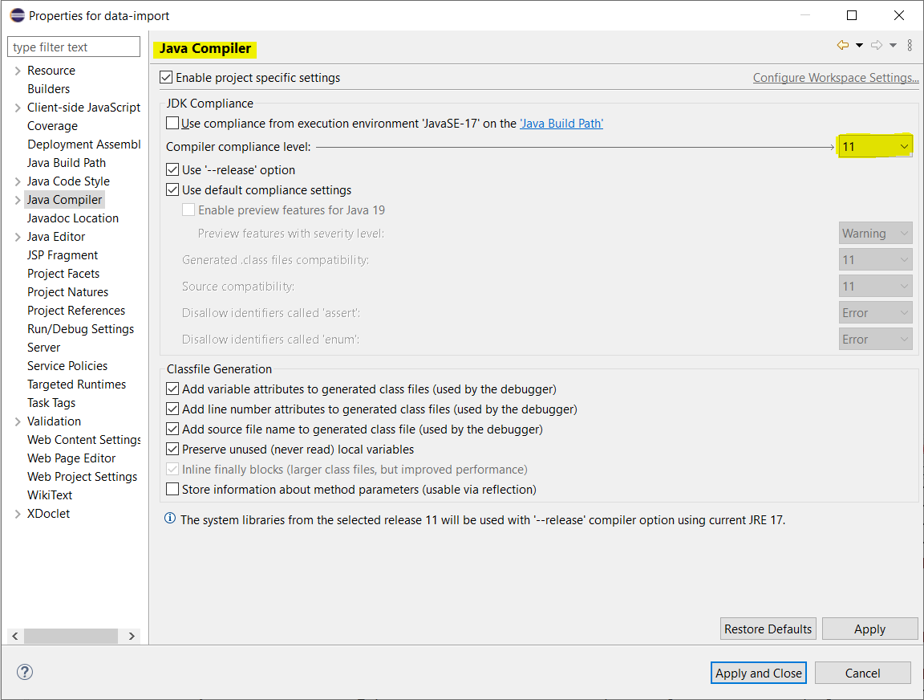

1. Module can be registered with the EBX by defining the class extending the EBX extending the EBX class Module Registration Servlet. Create the class inside the package created above.

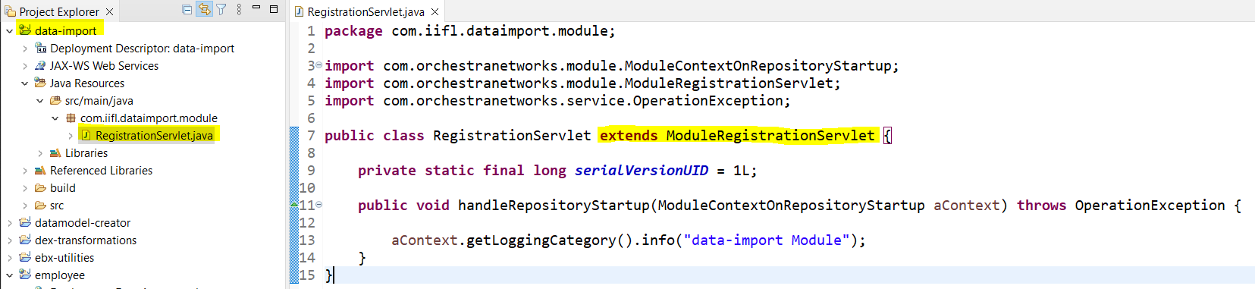

1. Once the class is created make the servlet entry inside the web.xml file.

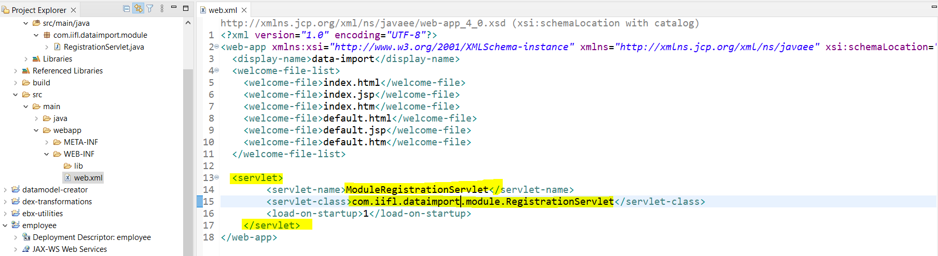

1. Create ebx folder inside the WEB-INF folder. And also create the module.xml inside the WEB-INF folder.

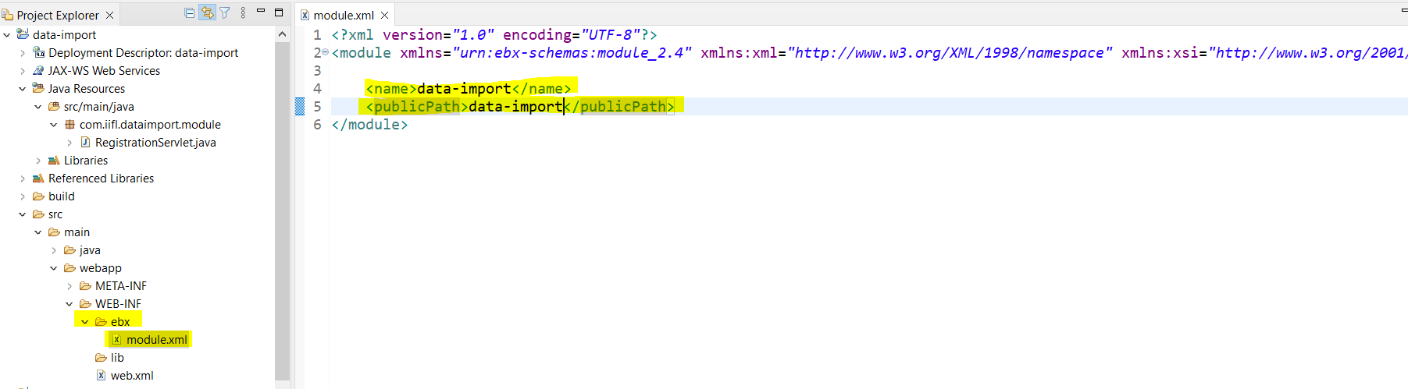

1. Ensure that you set the class file generation location to classes folder inside the WEB-INF folder. This can be done through the Configure build path window.

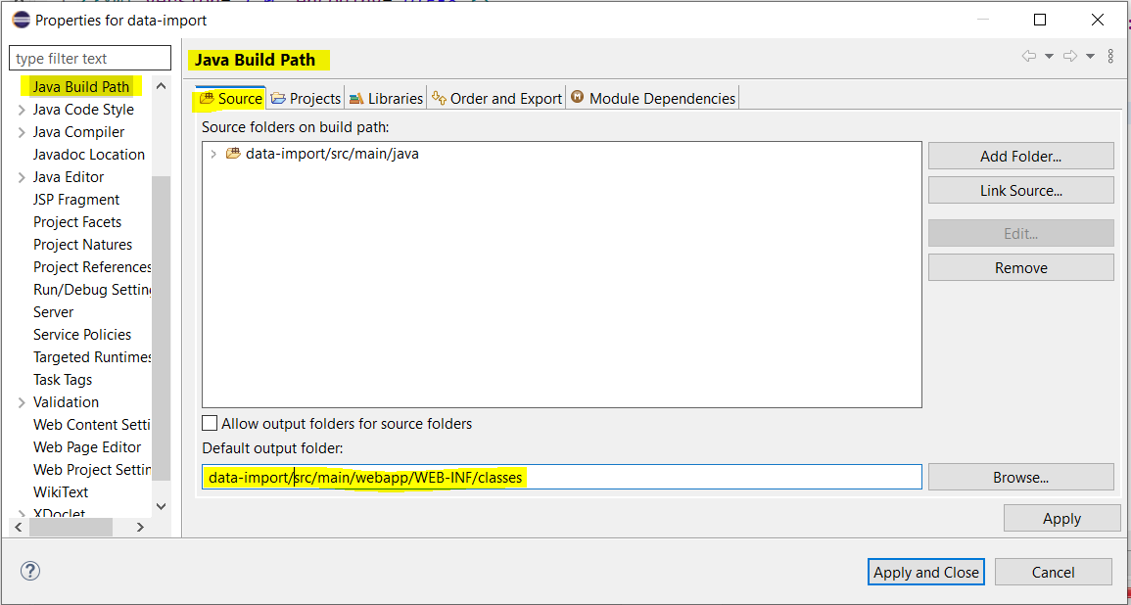

1. Make entry in the tomcat server.xml file of the tomcat. In doc base the path is relative to the location of the file server.xml.

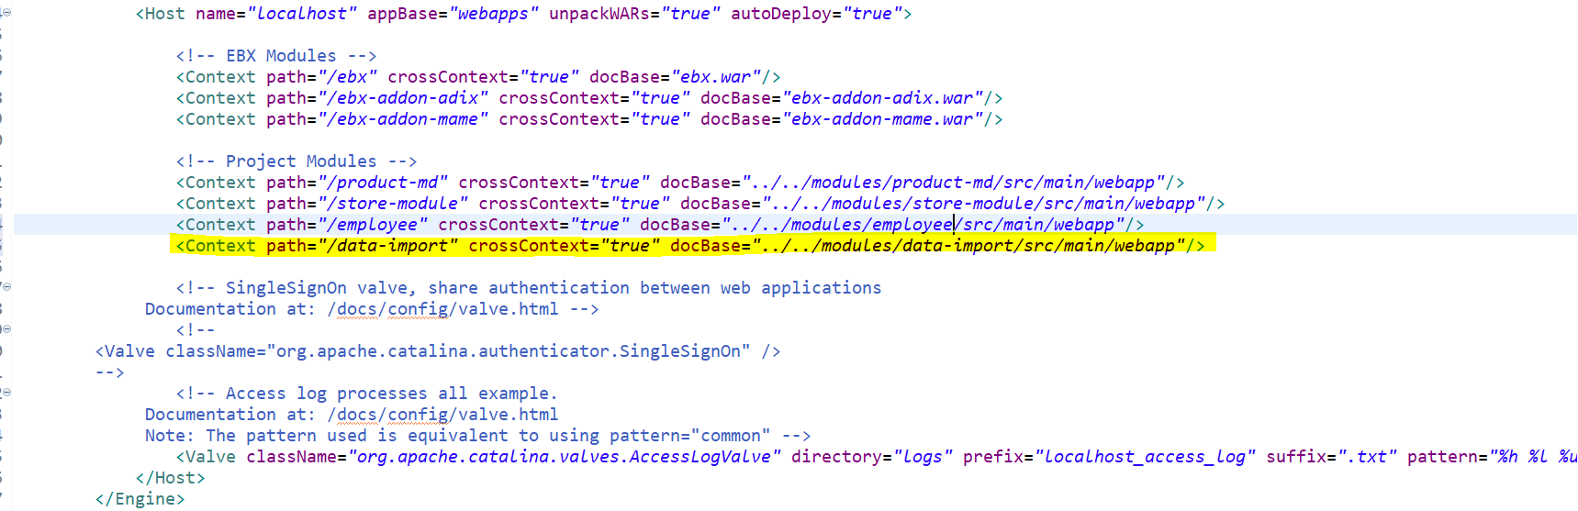

1. Restart the EBX server.
2. Check in the Modules and data model screen of the TIBCO EBX if the module is registered.

